Bitcode:

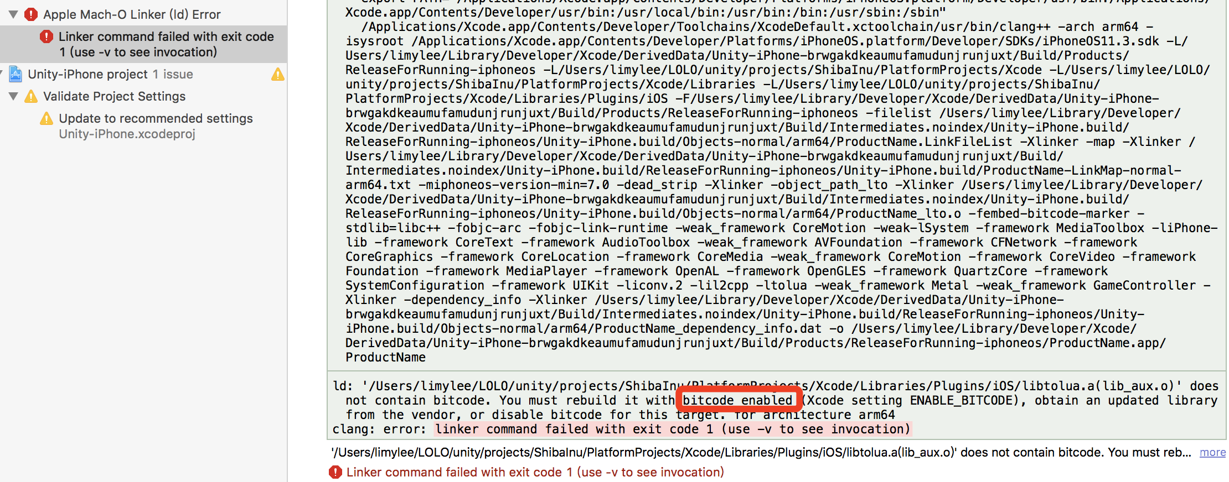

解决：

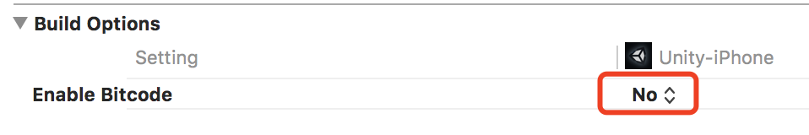

Add Copy Res Script:

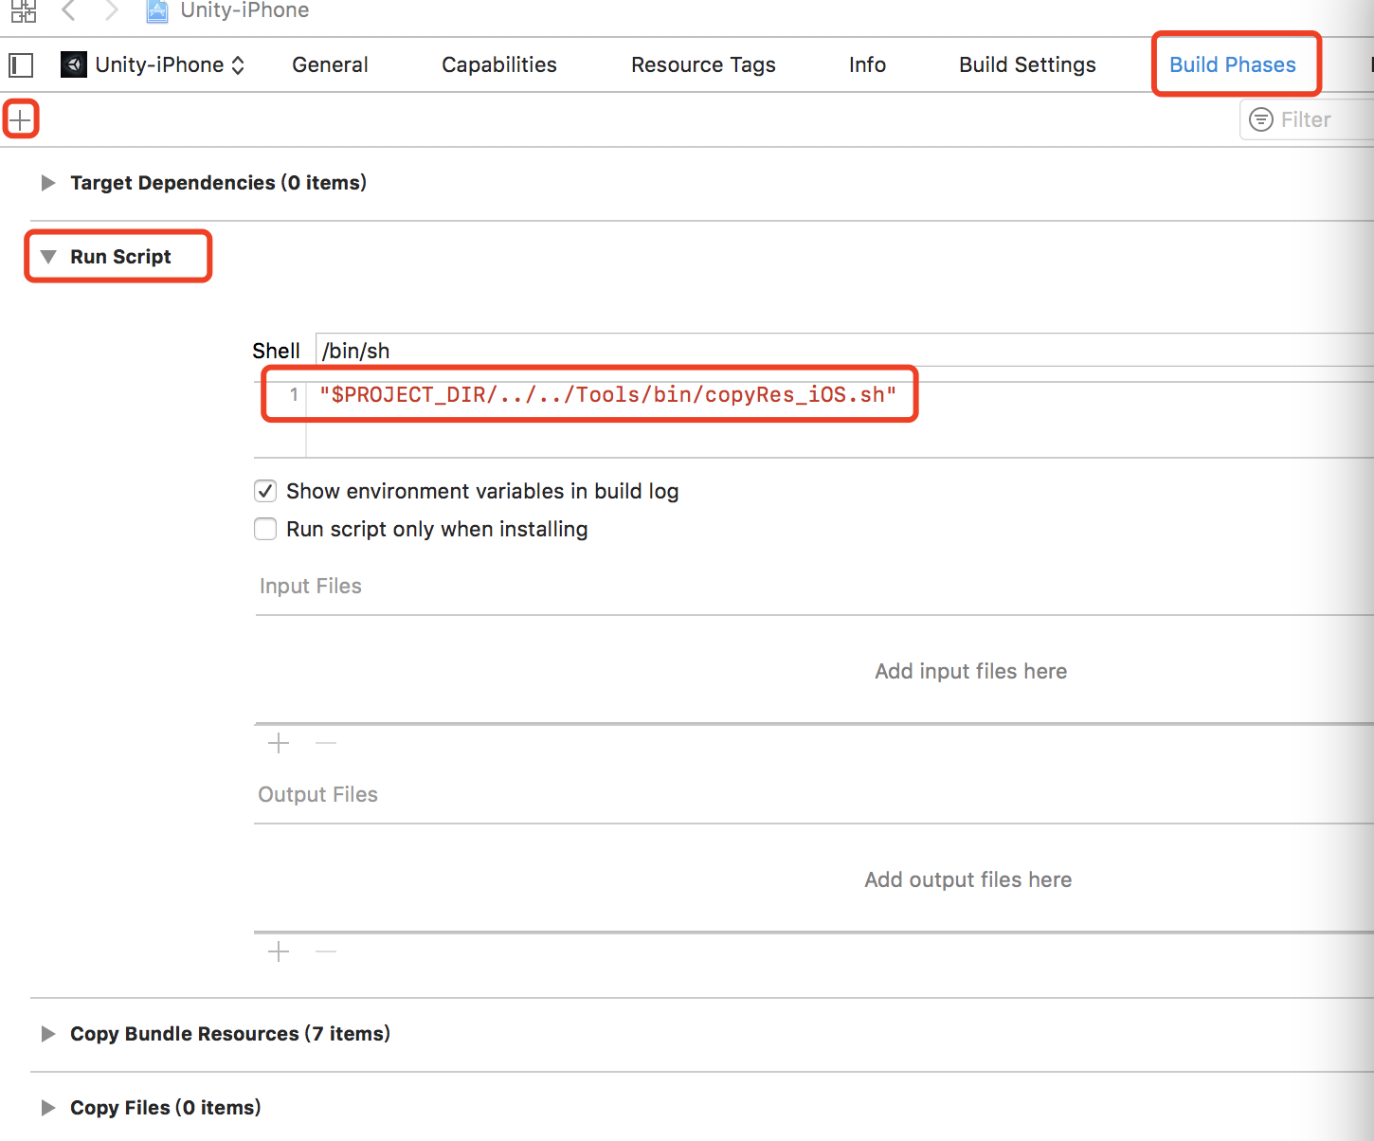

"$PROJECT_DIR/../../Tools/bin/copyRes_iOS.sh"